Water phase models
Water is a critical material for modern living. It is used for many contemporary applications, including electricity generation, food/biological processing, and weather calculations, and many more. The diagram below shows the familiar P-V diagram for water. The liquid-vapor equilibrium curve is particularly important for many engineering and biological applications.
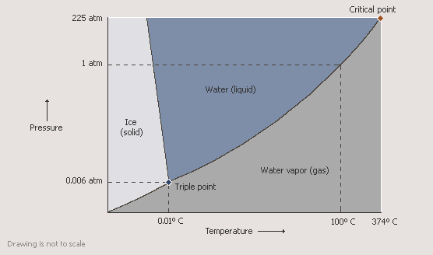
Engineering applications that use this information require more quantitative values for this equilibrium curve. This is accomplished through the development of numerical and analytical models.
Steam Tables
You should all be familiar with the steam tables, which provide quantitative information for the liquid-vapor behavior of water. The tables are a very simple numerical model composed of values. In your prior work, you should have learned how to manually read and use these tables to get values for water properties at different conditions. Quantative computational models can be created for water (you didn’t think all the numbers were measured!) See STEAM application and INTERPOL.PPT, if needed, or find steam tables information on internet. These are based on equations of state, such as Van der Waals or the Peng-Robinson models. Simple models for vapor pressure can also be used over limited ranges, such as Anotine’s equation.
Antoine equation model
The Antoine equation is a simple quantitative analytical model for general liquid-vapor equilibrium behavior. It is a 3 constant model relating saturated pressure and temperature, intended to quantify the P-T vapor-liquid equilibrium behavior of materials.
To develop the mechanistic features of this model, for a 2 phase L-V mixture at saturated conditions, the relationship between the vaporization pressure and temperature can be obtained by considering the thermodynamic energetic state of each phase.
Equilibrium requires that the specific Gibb’s energy in each phase be the same, i.e.
dG_{L} = dG_{V}
We also recognize that during a phase change the temperature and pressure are also constant
Since dG=VdP - SdT,
dG_{L} = V_{L}dP - S_{L}dT =V_{V}dP -S_{V}dT = dG_{V}
Since T and P are fixed at saturated conditions
Re-arranging,
dPsat/dTsat = (S_{L} - S_{V})/(V_{L} - V_{V}) =ΔSvap/ΔVvap
Enthalpy is defined as dH = TdS + VdP
Since during a phase change, dP=0,
dHvap =Tsat dSvap
integrating and re-arranging,
ΔSvap = ΔHvap/Tsat
Substituting this into the previous equation gives the familiar Clapeyron Equation:
dP/dT = ΔHvap/[T*(V_{L} - V_{V})]
Assuming that V_{L}<<V_{V}, that ΔHvap is constant, and the ideal gas law is valid, and doing a little algebraic re-arrangement gives:
dP/P = -ΔH/R * dT/T²
Integrating both sides gives,
ln P = W - ΔHvap/(R*T)
where W is a constant.
This equation is generalized to the form of the Antoine equation as:
ln Psat = A - B/(C+Tsat)
where A, B, and C are constants that depend the substance.
Antoine parameters for water are:
A: 8.07131 B: 1730.63 C: 233.426 for 1<T<100 C
A: 8.14019 B: 1810.94 C: 244.485 for 99<T<374 C
You will note that these values are based on numerically fitting the Antoine equation to measured water properties, hence the use of 2 different fitted equations used to more precisely fit the data over 2 different temperature ranges. (Recall that you can use LSC regression to fit a function to data values.)
Critical property models (van der Waals, Peng-Robinson, etc.)
Alternatively, starting from a theoretical approach, the properties of water can be predicted more comprehensively. Using thermodynamic phase equilibrium theory, Van der Waals derived a 3 parameter model based on the critical properties of materials. Unlike simpler equations of state (e.g. ideal gas, Antoine, etc.), this model has strong fundamental/theoretical foundations and is based on critical properties of materials instead of numerical fits to vapor-liquid equilibria data. Hence, these 3 parameter models can predict both liquid and vapor properties and are often used as the basis for creating quantitative values, such as the steam tables.
See EOS history, EOS.PPT, and PREOS.xls files or search Peng-Robinson Equation of State on internet.

